MAKING WAVES
Interactive Ship Navigation System
Project Documentation & Usage Instructions

Developed for the Queensland Maritime Museum
Piper Hofstee & Tynan Jones
CSSE4011 — Advanced Embedded Systems

1. Project Overview
Making Waves is an interactive embedded systems exhibit designed for the Queensland Maritime Museum. Inspired by the voyage of Jessica Watson, the exhibit lets visitors physically steer a virtual ship using a real ship's wheel equipped with an IMU sensor.
RFID keepsake cards act as tokens that visitors collect before beginning their voyage. The system communicates wirelessly over BLE NUS protocol and displays a real-time ship navigation simulation on a Python GUI.

1.1 System Architecture
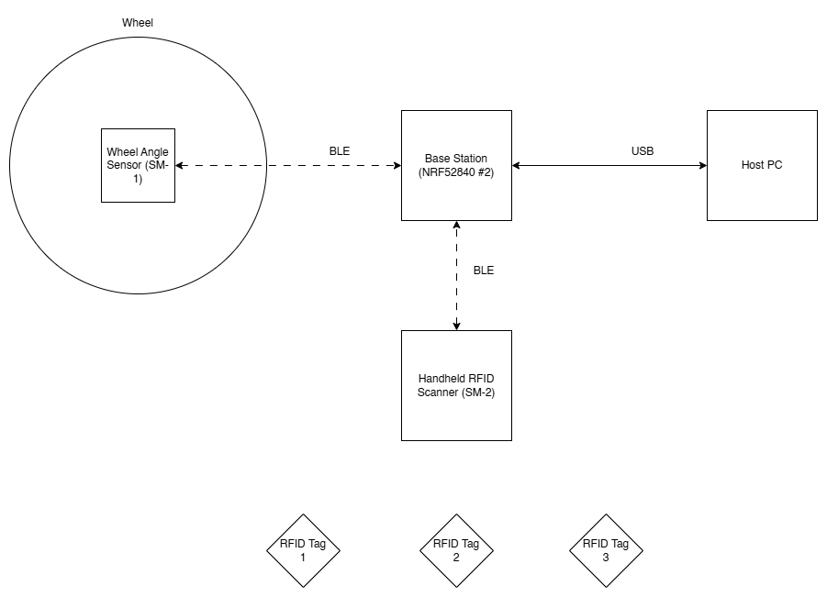
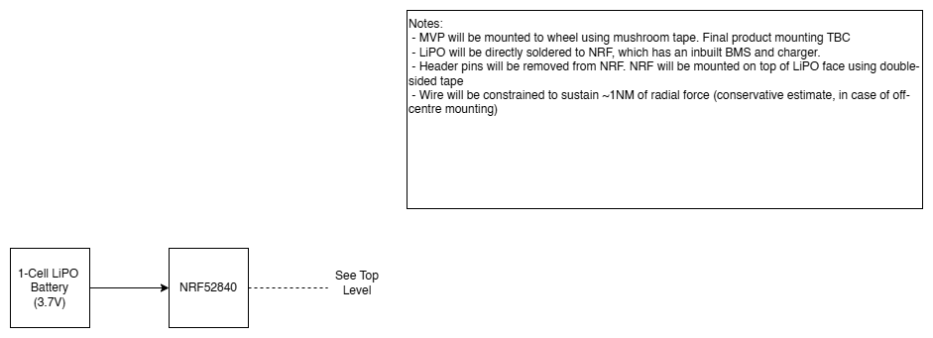
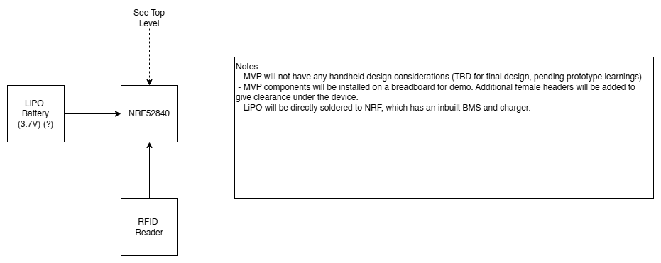

1.2 Hardware Components
Component | Description
IMU Node | Seeed XIAO nRF52840 Sense.  Onboard LSM6DS3TR-C IMU
RFID Node | Seeed XIAO nRF52840  RC522 RFID reader
Base Station | Seeed XIAO nRF52840
RFID Fobs | Mifare Classic 13.56MHz fobs
GUI Computer | MacOS / Ubuntu / Windows PC with USB port
Ship Wheel | Physical steering wheel mounted with IMU node

2. Node Descriptions

2.1 IMU Node
The IMU node is mounted on the ship's wheel and measures rotational motion using the onboard LSM6DS3TR-C 6-axis IMU. It implements a simple sensor fusion algorithm, combining gyroscope integration with an accelerometer based drift correction to produce a stable steering angle output.

Sensor Fusion Algorithm
- Gyroscope Z-axis is integrated at 100Hz to track cumulative rotation
- A low-pass filter (alpha = 0.2) smooths gyro noise
- A deadband threshold (0.3 deg/s) suppresses noise when the wheel is still
- Accelerometer provides within-revolution reference to gravity for drift correction
- Complementary filter blends both: 99.5% gyro, 0.5% accel correction per sample

BLE Output (JSON over NUS)
{"SteeringAngle": 45.1234, "CumAngle": 45.1234, "GyroZ": 0.4593}
Transmitted every 5 samples (50ms) to the base station over BLE NUS notifications.

Received Commands
Command | Action
zero | Resets cumulative angle, steering angle and gyro filter to 0
collision | Flashes red LED for 250ms

2.2 RFID Node
The RFID node reads Mifare RFID fobs using an RC522 reader connected via SPI. When scanned, it identifies cards by UUID, and sends a JSON packet over BLE NUS. It also stores the current difficulty setting and a scan log in non-volatile memory so it persists across reboots. Scans collected while offline are automatically delivered on the next BLE connection (acting as a data mule).

Known Cards
Colour | UID
Yellow | 4D:4E:C0:01
Green | 4E:E5:C0:01
Purple | B2:7C:C7:01

BLE Output (JSON over NUS)
{"TYPE": "rfid", "SCANNED": "yellow"}

Difficulty-Based LED Behaviour
Difficulty | LED Behaviour
Easy | Only yellow card flashes yellow. Others flash white
Medium | Yellow and green flash their colour. Purple flashes white
Hard | All cards flash their respective colour

Received Commands
Command | Action
esy | Sets difficulty to easy, saves to non-volatile memory, flashes green
med | Sets difficulty to medium, saves to non-volatile memory, flashes yellow
hrd | Sets difficulty to hard, saves to non-volatile memory, flashes purple

2.3 Base Station
The base station acts as a BLE central node, connecting to multiple NUS peripherals simultaneously (up to 2). It receives data from the IMU and RFID nodes, parses JSON packets, and forwards information as necesssary over UART to the Python GUI. It also receives commands from the GUI and forwards them to the appropriate node.

UART Command Interface
The base station accepts JSON commands over UART:
Command JSON | Action
{"Command":"zero"} | Sends zero command to IMU node
{"Command":"collision"} | Sends collision alert to IMU node
{"Command":"difficulty","Mode":"easy"} | Sends difficulty to RFID node
{"Command":"difficulty","Mode":"medium"} | Sends difficulty to RFID node
{"Command":"difficulty","Mode":"hard"} | Sends difficulty to RFID node

3. Python GUI
The Python GUI is a pygame-based ship navigation simulation that runs on macOS, Windows and Linux. It connects to the base station over a USB serial interface, and provides a visual display for the Making Waves experience.

3.1 Installation

Requirements
- Python 3.12 (recommended)
- pip packages: pygame, pyserial, numpy

macOS Setup
source /path/to/.venv/bin/activate
pip install pygame pyserial numpy
python ship_navigation-4.py

Windows Setup
python -m venv .venv
.venv\Scripts\activate
pip install pygame pyserial numpy
python ship_navigation-4.py

Linux Setup
python3 -m venv .venv
source .venv\Scripts\activate
pip install pygame pyserial numpy
python ship_navigation-4.py

Optional: Music
Place a music file named kids.mp3 in the same folder as ship_navigation.py. Convert from m4a using:
ffmpeg -i "Kids.m4a" kids.mp3

3.2 Command Line Options
Command | Description
python ship_navigation-4.py | Launch with port selector GUI
python ship_navigation-4.py --port COM3 | Auto-connect to specified port
python ship_navigation-4.py --baud 115200 | Set baud rate (default 115200)
python ship_navigation-4.py --list-ports | List available serial ports

3.3 Screen Flow
Screen | Description
1. Home / Connection Screen | Select serial port, choose difficulty, connect to base station
2. Keepsafe Collection Screen | Scan required RFID cards to unlock the voyage
3. Ready to Sail Countdown | 3-2-1-GO countdown before gameplay begins
4. Navigation Screen | Ship navigation with real-time IMU steering

3.4 Navigation Screen Controls
Control | Action
Ship's Wheel (IMU) | Steers the ship — left/right rotation
Arrow Keys | Demo mode steering (debugging without UART)
SPACE | Skip current screen (demo mode)
ESC | Quit application
Zero IMU button | Resets steering angle on IMU node to zero
Home button | Return to connection screen

3.5 HUD Display
Field | Description
Heading | Current ship heading in degrees (0-360)
Cum angle | Cumulative steering angle from IMU
Delta | Change in angle since last packet
GyroZ | Raw gyroscope Z reading (deg/s)
UART | Connection status — green = connected, red = disconnected

4. Difficulty System
The difficulty setting controls how many RFID keepsafe cards must be collected before the voyage can begin. It is set on the home screen and transmitted to the RFID node when connecting.

Difficulty | Cards Required
Easy | 1 card required — yellow only
Medium | 2 cards required — yellow and green
Hard | 3 cards required — yellow, green and purple
The difficulty setting is saved to non-volatile flash memory on the RFID node and persists across power cycles. When a new difficulty is received the scan log is also cleared, as a new game has started.

5. Obstacles
The navigation screen contains fixed obstacles — rocks and lighthouses — that the ship must avoid. Colliding with an obstacle sends a collision command to the IMU node which flashes the red LED.

Obstacle | Description
Rocks | 7 rocks scattered around the ocean — bumpy polygon shape
Lighthouses | 2 lighthouses with rotating light beams and pulsing glow
The ship bounces off obstacles with a reflection heading. A 2-second cooldown prevents the collision command from spamming.

6. Zephyr RTOS Features

6.1 Kernel Features Used
Feature | Usage
k_msleep / k_sleep | Kernel sleep for timing control
k_sem_give / k_sem_take | Semaphores for localisation synchronisation
k_mutex_lock / unlock | Mutexes for beacon list thread safety
k_work_schedule | Delayable work queues for BLE advertising restart
k_msgq_get | Message queues for UART receive thread
K_THREAD_DEFINE | Kernel thread for UART receiver
k_uptime_get | Kernel timing for timestamps
task_wdt | Task watchdog on IMU accel data

6.2 File System
The RFID node uses Zephyr's NVS (Non-Volatile Storage) subsystem to persist the difficulty setting and log of scanned RFID cards across power cycles. NVS is stored in the flash storage partition. Scans are stored offline and delivered when BLE connectivity is restored.

6.3 Low Power Considerations
Feature | Implementation
SPI low-power pinctrl | SPI pins configured with low-power-enable in sleep state
LED management | LEDs always turned off after flash_colour() completes
Disable unused peripherals | Any unused peripheral modules have been disabled
Battery Hardware Spec | Battery has been estimated to last 7 days under current power conditions

6.4 Sensor Data Fusion
The IMU node implements a complementary filter combining gyroscope and accelerometer data. Each sensor compensates for the other's weakness: the gyroscope tracks fast rotation accurately but drifts over time, while the accelerometer provides a drift-free absolute reference but is noisy. The complementary filter blends them with a 99.5/0.5 ratio per sample.

7. Troubleshooting

7.1 GUI Issues
Problem | Solution
No module named pygame | Activate venv and run: pip install pygame pyserial numpy
Port not appearing | Click Refresh button or check USB connection
Music not playing | Place kids.mp3 in same folder as ship_navigation.py
Ship direction reversed | Check IMU orientation on wheel — flip GYRO_Z_SIGN in firmware

7.2 Firmware Issues
Problem | Solution
RC522 version 0x00 | Checked MISO/MOSI wiring and CS pin connection
RC522 version 0xFF | MISO wire was not connected or floating
BLE connection fails | Check device name matches target_names[] in base station

8. Pin Mappings

8.1 RFID Node — RC522 to XIAO nRF52840
RC522 Pin | XIAO Pin
SCK (clock) | D8 → P1.13
MOSI (data out) | D10 → P1.15
MISO (data in) | D9 → P1.14
SDA (chip select) | D4 → P0.04
RST (reset) | D3 → P0.29
3.3V | 3V3
GND | GND

